**Kyla Alburo Hubahib**

**Magsaysay Hills, Poblacion**

**Toledo City, Cebu 6038**

May 25, 2024

**Ma’am Angeli Nicole Perales**

Sangi, Toledo City

Dear Ma’am Angeli,

I, **Kyla Hubahib**, am writing this letter to indicate that I authorize **Jessica Albur**o to act on my behalf with regards to claiming this month’s stipend while I am attending face to face classes in Cebu Technological University, and he/she is to make the necessary arrangements as she fits.

I appreciate Ma'am Angeli’s assistance in this matter.

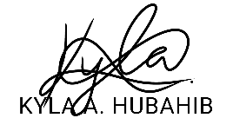Yours Sincerely,

